1. Deploy Your flask backend and express frontend in amazon single ec2 instance.

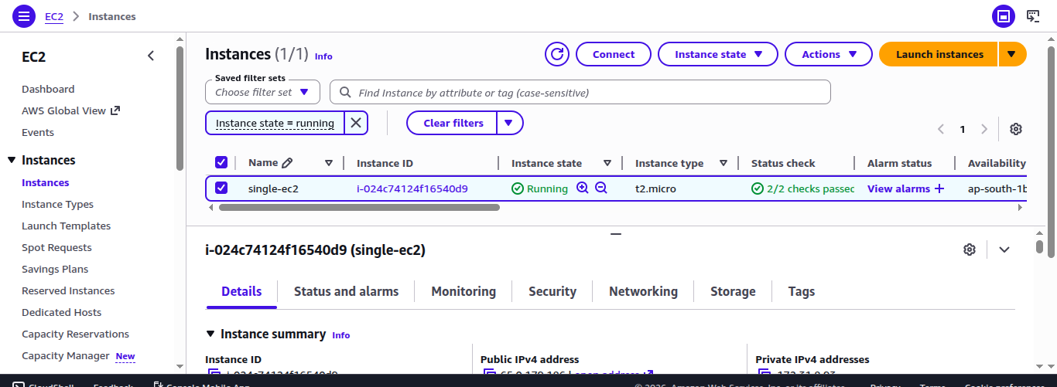

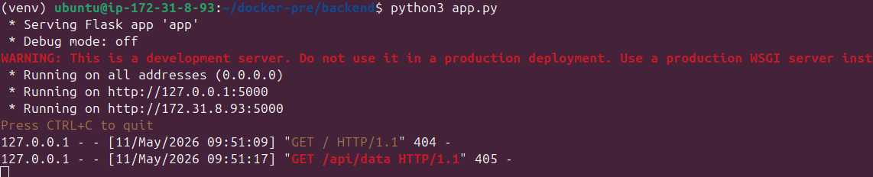

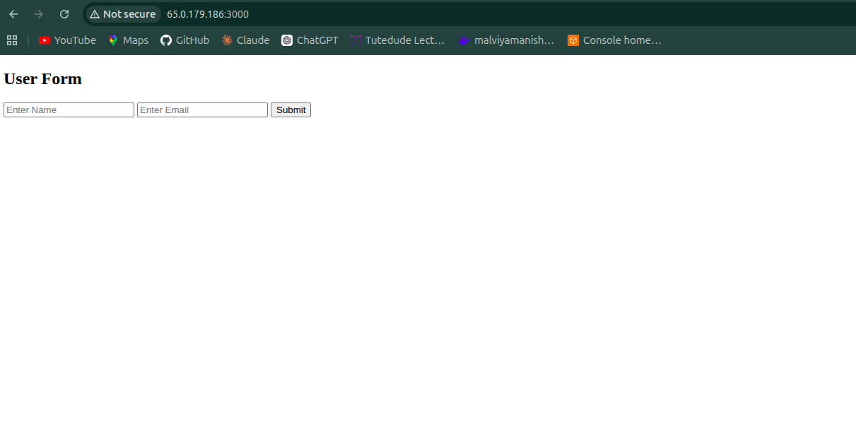

- Single EC2 Deployment
Frontend URL:
http://PUBLIC_IP:3000
Backend URL:
http://PUBLIC_IP:5000

Technologies Used
- AWS EC2
- Ubuntu
- Flask
- Express.js
- Security Groups

2. Deploy Your flask backend and express frontend in separate ec2 instances.
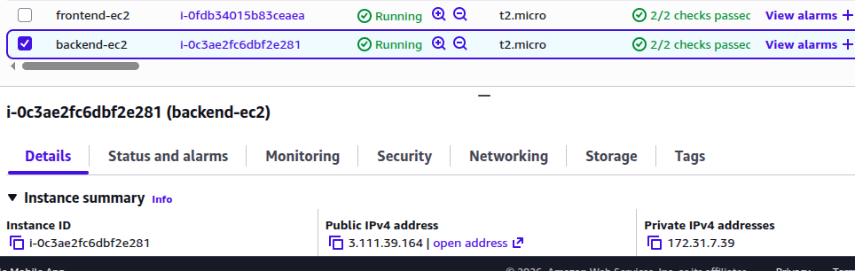

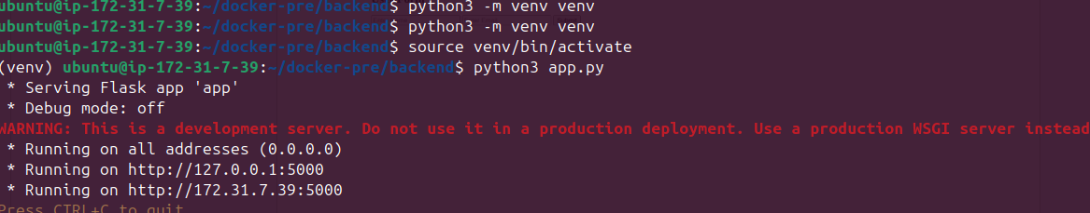
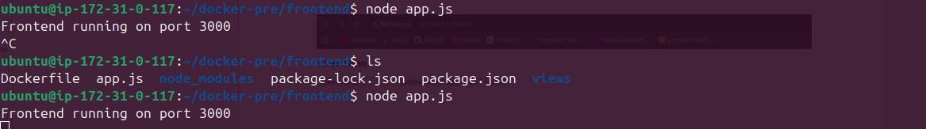

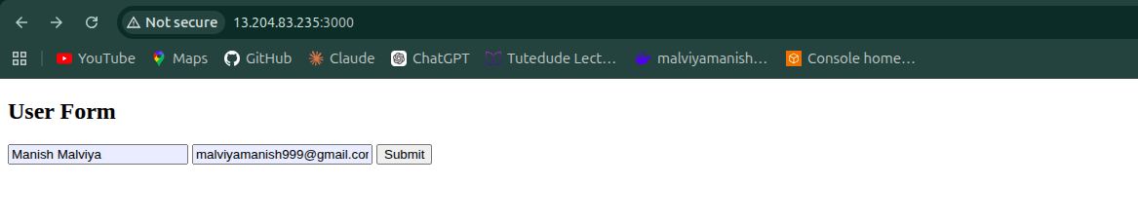

2. Separate EC2 Deployment
Frontend URL:
http://FRONTEND_PUBLIC_IP:3000
Backend URL:
http://BACKEND_PUBLIC_IP:5000

Technologies Used
- AWS EC2
- Flask
- Express.js
- Security Groups
- Public Networking

3. Deploy Your flask backend and express frontend Docker Container using aws ecr, ecs and vpc services
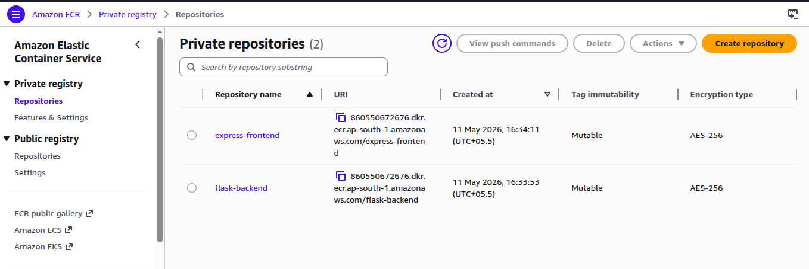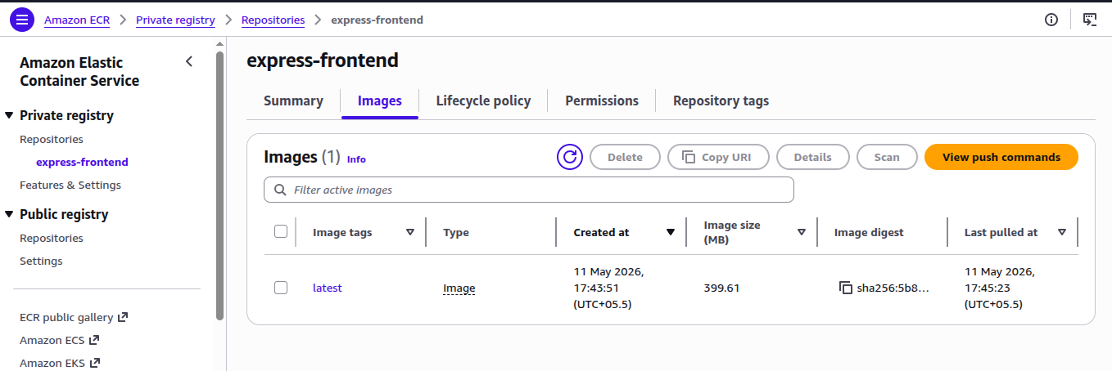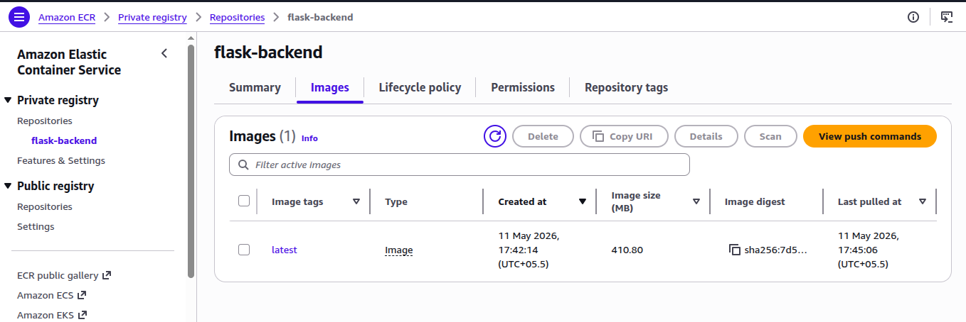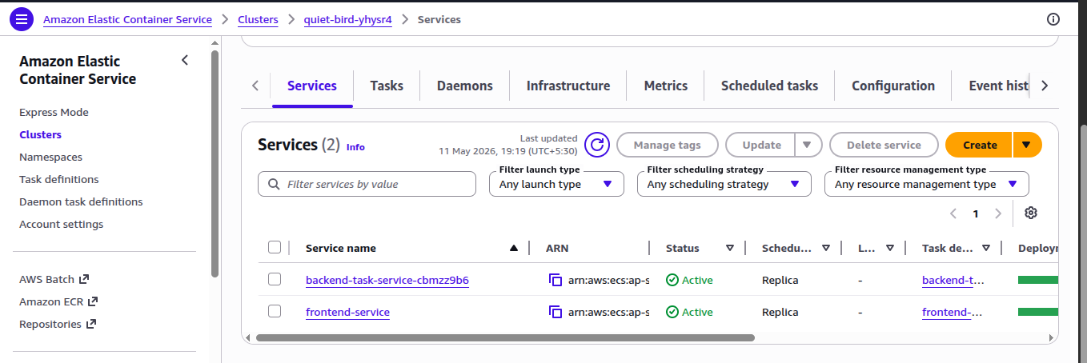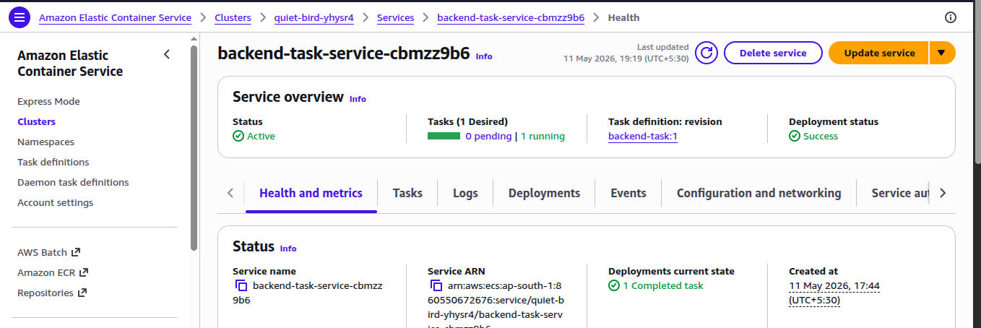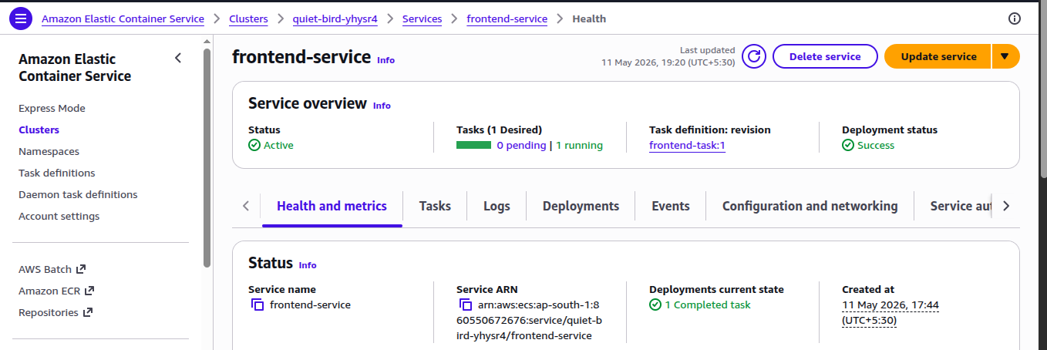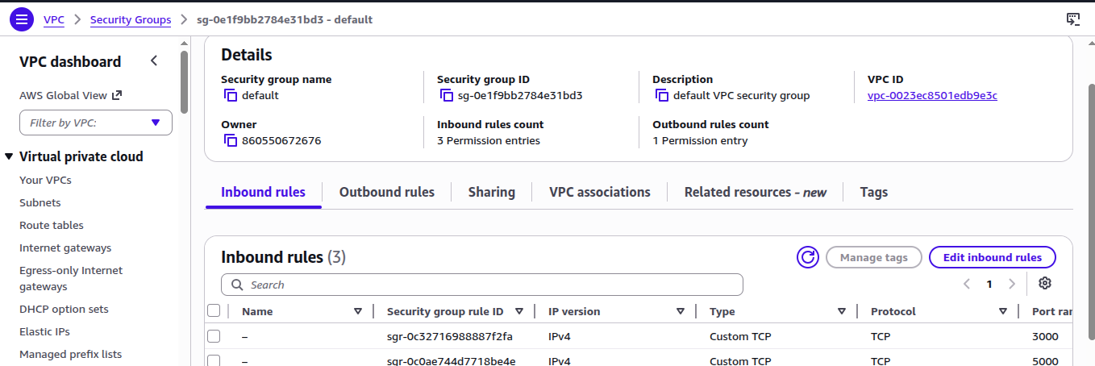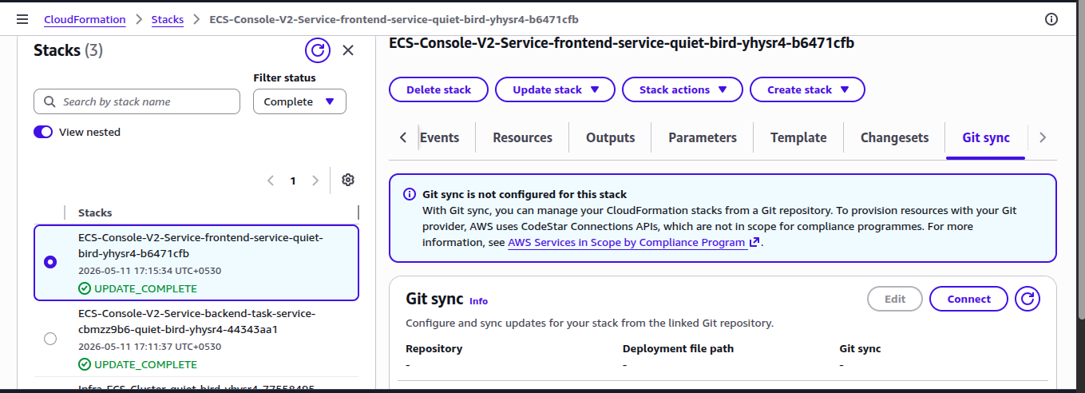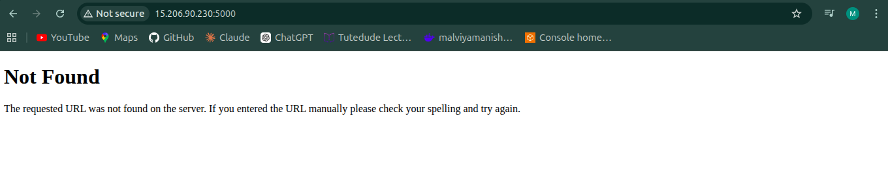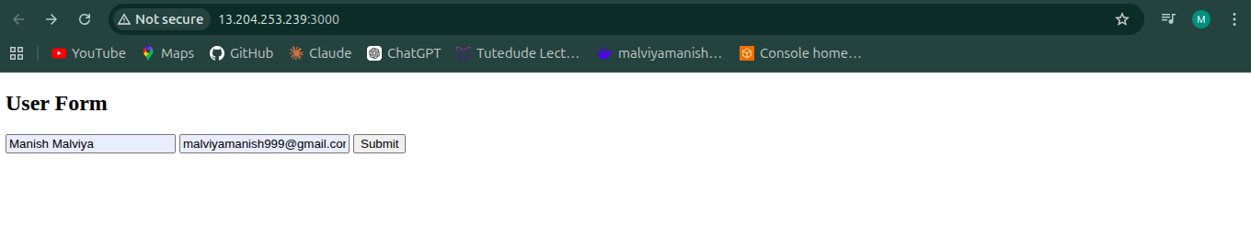

3 Docker + ECR + ECS Deployment
Frontend URL:
http://ECS_PUBLIC_IP:3000
Backend URL:
http://ECS_PUBLIC_IP:5000

Technologies Used
- Docker
- Docker Compose
- AWS ECR
- AWS ECS (Fargate)
- AWS VPC
- IAM

Docker Commands Used

Build Images
docker build -t flask-backend ./backend
docker build -t express-frontend ./frontend

Push Images to ECR
docker push <ECR_BACKEND_URL>
docker push <ECR_FRONTEND_URL>

